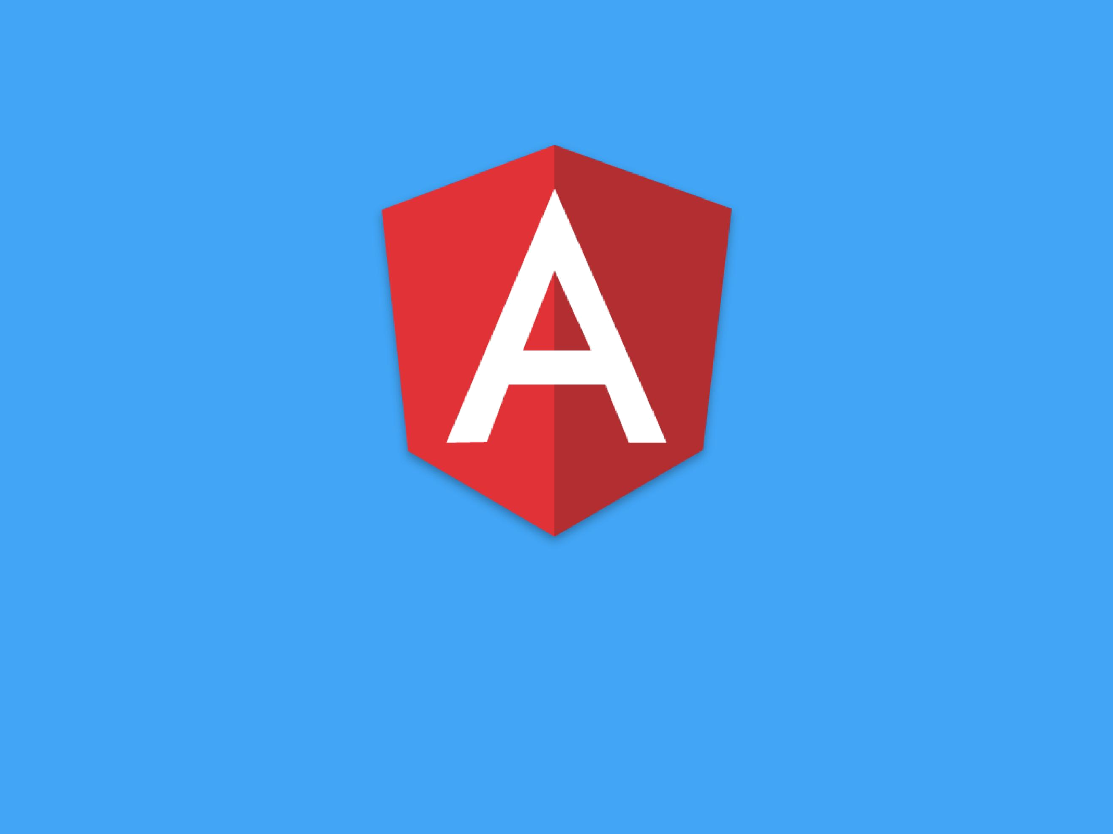

Build Better Apps
with Angular 2


Strong grasp on how to build a single, basic feature in Angular 2

Agenda

The Angular 2 Big Picture
Prerequisite Primer in Tooling
Component Fundamentals
Templates
Services
Routing


The Angular 2 Big Picture


The Demo Application

- A simple web application with basic features

- We will be building out a new widgets feature

- Feel free to use the existing code as a reference point

- Please explore! Don't be afraid to try new things!
bit.ly/
Why Angular 2?

- Distilled all the best practices of Angular 1.x into Angular 2

- By focusing on standards, we get twice the power with half the framework

- Dramatically improved changed detection with a relentless focus on speed and performance
- Reactive mechanisms baked into the framework 

- Teamwork! The Angular team is working with some really smart people from other projects to make Angular and web development awesome
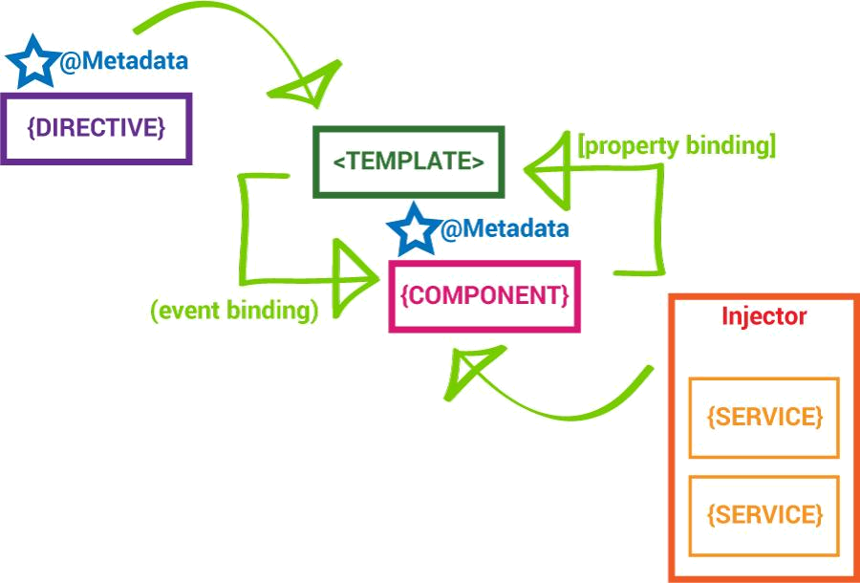

The Big Picture

The Main Building Blocks

- Module

- Component

- Metadata

- Template

- Data Binding

- Service

- Directive

- Dependency Injection

Bootstrapping the App

- Import the bootstrap module

- Import your top-level component

- Import application dependencies

- Call bootstrap and pass in your top-level component as the first parameter and an array of dependencies as the second

import {bootstrap} from 'angular2/platform/browser'; import {ROUTER_PROVIDERS} from 'angular2/router'; import {AppComponent} from './app.component';

bootstrap(AppComponent, [ ROUTER_PROVIDERS

]);

Bootstrap

Module

- Uses ES6 module syntax

- Angular 2 applications use modules as the core mechanism for composition

- Modules export things that other modules can import

- Keep your modules fine-grained and self-documenting

- In home.component.ts export class HomeComponent { }

- In app.component.ts

import {HomeComponent} from './home/home.component';

Module

Component

- Components are just ES6 classes

- Providers (Services) are injected in the constructor

- Need to explicitly define providers and directives within the component decoration

- Hook into the component lifecycle with hooks

- Properties and methods of the component class are available to the template

export class HomeComponent implements OnInit{ title: string = 'Home Page';

body: string = 'This is the about home body'; message: string;

constructor(private _stateService: StateService) { }

ngOnInit() {

this.message = this._stateService.getMessage();

}

updateMessage(m: string): void { this._stateService.setMessage(m);

}

}

Component

Metadata

- Metadata allows Angular to process a class

- We can attach metadata with TypeScript using decorators

- Decorators are just functions

- Most common is the @Component() decorator

- Takes a config option with the selector, template(Url), providers, directives, pipes and styles

@Component({ selector: 'home',

templateUrl: 'app/home/home.component.html'

})

export class HomeComponent{ }

Metadata

Template

- A template is HTML that tells Angular how to render a component

- Templates include data bindings as well as other components and directives

- Angular 2 leverages native DOM events and properties which dramatically reduces the need for a ton of built-in directives

- Angular 2 leverages shadow DOM to do some really interesting things with view encapsulation
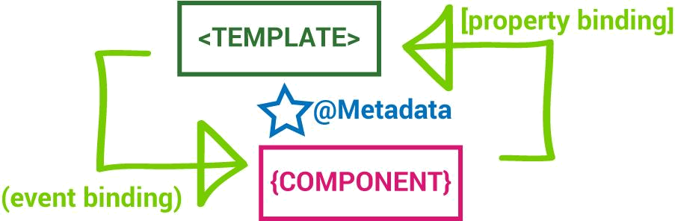

Template

@Component({

selector: 'experiment',

templateUrl: './experiment.detail.component.html', styles: [`

.experiment { cursor: pointer;

outline: 1px lightgray solid; padding: 5px;

margin: 5px;

}

`]

})

Template

@Component({

selector: 'experiment', template: `

<div class="experiment" (click)="doExperiment()"> <h3>{{ experiment.name }}</h3>

<p>{{ experiment.description }}</p> <p><strong>{{experiment.completed}}</strong></p>

</div> `, styles: [`

.experiment { cursor: pointer;

outline: 1px lightgray solid; padding: 5px;

margin: 5px;

}

`]
})

Template

Data Binding

- Enables data to flow from the component to template and vice-versa

- Includes interpolation, property binding, event binding, and two-way binding (property binding and event binding combined)

- The binding syntax has expanded but the result is a much smaller framework footprint
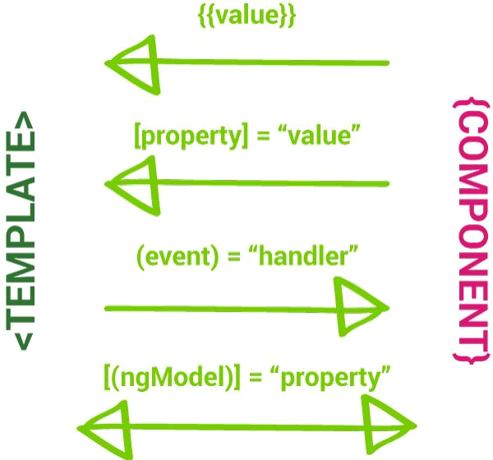

Data Binding

<h1>{{title}}</h1> <p>{{body}}</p> <hr/>

<experiment *ngFor="#experiment of experiments" [experiment]="experiment"></experiment>

<hr/> <div>

<h2 class="text-error">Experiments: {{message}}</h2> <form class="form-inline">

<input type="text"

[(ngModel)]="message" placeholder="Message"> <button type="submit" class="btn"

(click)="updateMessage(message)">Update Message </button>

</form> </div>

Data Binding

Service

- A service is just a class

- Should only do one specific thing

- Take the burden of business logic out of components

- Decorate with @Injectable when we need to inject dependencies into our service

import {Injectable} from 'angular2/core'; import {Experiment} from './experiment.model';

@Injectable()

export class ExperimentsService { private experiments: Experiment[] = [];

getExperiments(): Experiment[] { return this.experiments;

};

}

Service

Directive

- A directive is a class decorated with @Directive

- A component is just a directive with added template features

- Built-in directives include structural directives and attribute directives

import { Directive, ElementRef } from 'angular2/core';

@Directive({

selector: '[femBlinker]' })

export class FemBlinker { constructor(element: ElementRef) {

let interval = setInterval(() => {

let color = element.nativeElement.style.color; element.nativeElement.style.color

= (color === '' || color === 'black') ? 'red' : 'black'; }, 300);

setTimeout(() => { clearInterval(interval);

}, 10000); }

}

Directive

Dependency Injection

- Supplies instance of a class with fully-formed dependencies

- Maintains a container of previously created service instances

- To use DI for a service, we register it as a provider in one of two ways: when bootstrapping the application, or in the component metadata

// experiments.service.ts

import {Injectable} from 'angular2/core';

@Injectable()

export class ExperimentsService { }

// experiments.component.ts

import {ExperimentsService} from '../common/ experiments.service';

import {StateService} from '../common/state.service';

export class ExperimentsComponent { constructor(

private _stateService: StateService,

private _experimentsService: ExperimentsService) {}

}

Dependency Injection

Change Detection

- Checks for changes in the data model so that it can re-render the DOM

- Changes are caused by events, XHR, and timers

- Each component has its own change detector

- We can use ChangeDetectionStrategy.OnPush along with immutable objects and/or observables.

- We can tell Angular to check a particular component by injecting ChangeDetectorRef and calling markForCheck() inside the component

export interface Item { id: number;

name: string; description: string;

};

export interface AppStore { items: Item[]; selectedItem: Item;

};

Code Sample

Testing

- Angular wraps Jasmine methods

- Import all necessary Jasmine methods from angular2/ testing

- Import the classes to test

- Include providers by importing beforeEachProviders and then calling it with a method that returns an array of imported providers

- Inject providers by calling inject([arrayOfProviders], (providerAliases) => {}) inside a beforeEach or it block

import { describe, it, expect } from 'angular2/testing';

import { AppComponent } from './app.component';

describe('AppComponent', () => { it('should be a function', () => {

expect(typeof AppComponent).toBe('function'); });

});

Tests!

Architectural Best Practices

- Include all files pertinent to a component in the same folder

- Remember CIDER for creating components: (Create class, Import dependencies, Decorate class, Enhance with composition, Repeat for sub-components

- Keep templates small enough to put in the main component file directly

- Delegate business logic from the component to a provider

- Don’t be afraid to split a component up if it is growing too large

- Constantly consider change detection implications as you develop an app


Challenges

- Make sure that you can run the sample application

- Identify the major Angular 2 pieces in the sample application

- Add a new property to one of the feature components and bind to it in the view

- Add a new property to the StateService and consume it in a component

- BONUS Create an interface for the new property and type it in the StateService and your consuming component
i
Tooling Primer

- Module Loading

- Webpack

- ES6

- ES5

- TypeScript

- Typings
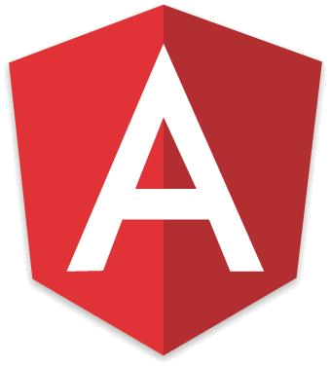
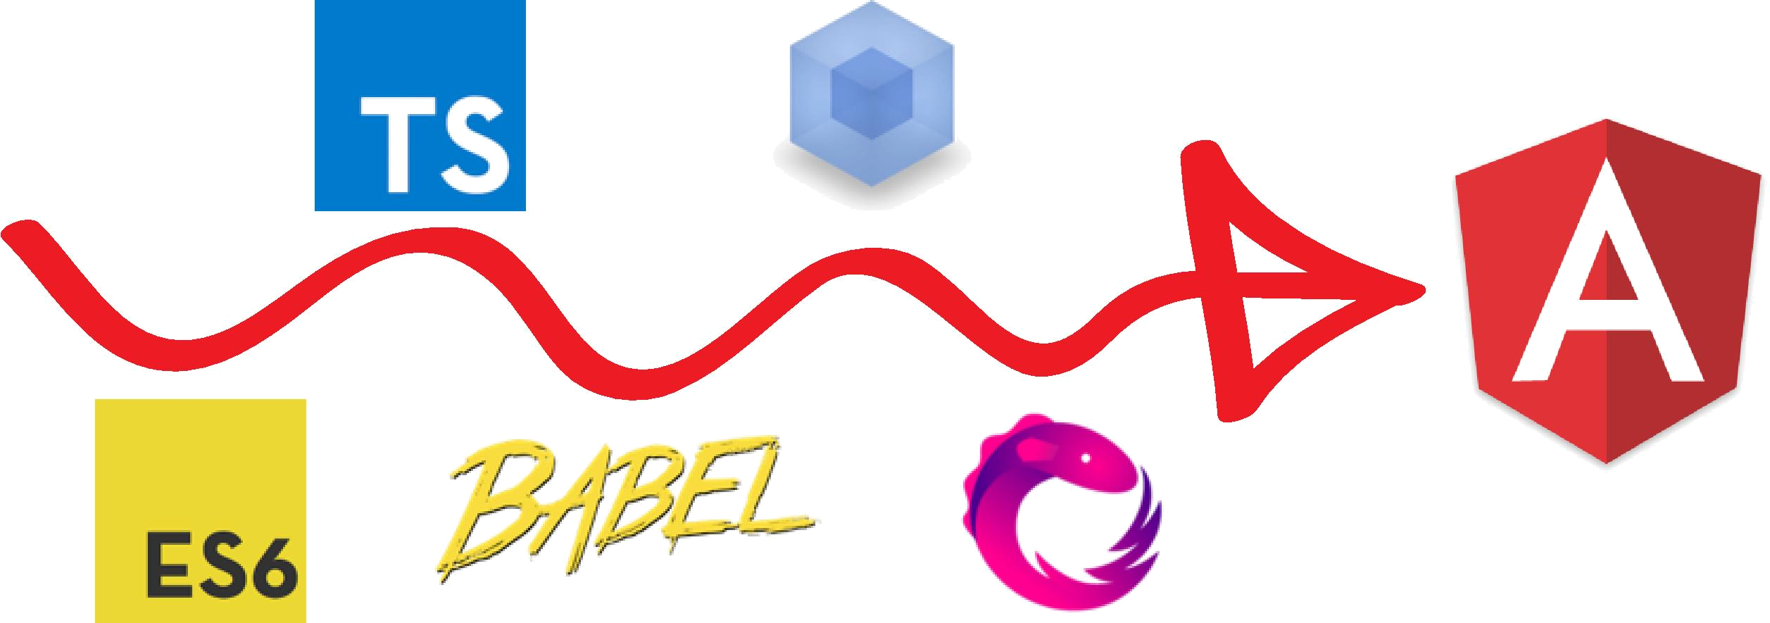

Module Loading

- Modular code is not required to develop with Angular, but it is recommended

- Allows us to easily use specific parts of a library

- Erases collisions between two different libraries

- We don’t have to include script tags for everything

- Because modules are not supported, we have to translate a module (file) to a pseudo module (wrapped function)

Webpack

- One of the most popular module loaders

- Allows us to include any sort of file as a module (CSS, JSON, etc.)

- Useful not only for module loading, but also the entire build process
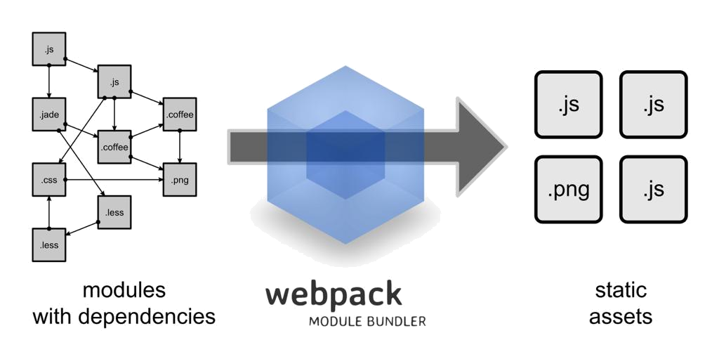

Webpack

ES6

- ES6/ES2015 is the latest standard for Javascript

- Comes with many helpful additions, such as a module system, new array methods, classes, multi-line templates, and arrow functions

- The most important features for us are modules and classes

- Although we don’t have to use it, it greatly enhances the development experience

- Classes and modules FTW!

class Point { constructor(x, y) {

this.x = x; this.y = y;

} toString() {

return `(${this.x}, ${this.y})`;

}

}

ES6 Class

TypeScript

- Is a typed superset of Javascript

- Is a compiled language, so it catches errors before runtime

- Includes the features of ES6 but with types, as well as better tooling support

- TypeScript allows us to decorate our classes via

@<Decorator> the syntax

- Classes, modules, types, interfaces and decorators FTW!

interface ClockInterface { currentTime: Date; setTime(d: Date);

}

class Clock implements ClockInterface { currentTime: Date;

setTime(d: Date) { this.currentTime = d;

}

constructor(h: number, m: number) { }

}

TypeScript Class

Typings

- We use the typings NPM package to handle the type definitions associated with third-party libraries

- By creating a postinstall script in package.json, we can install the appropriate typings immediately after all NPM packages have been downloaded

- To install a definition file for a particular library, run typings install -g <package> --ambient --save

- Treat the typings.json file just like the package.json file

Angular 2 with ES6

- Almost the same as TypeScript without types and interfaces

- Define dependency paramenters explicitly for DI to work properly

- Use the same build system, just switch out your transpiler (babel). Or use your TypeScript compiler and just not use TypeScript features

- Babel has experimental features that TypeScript does not

Angular 2 with ES5

- Supported natively

- No module system like angular 1.x. Use IIFE’s or other 3rd party module system

- Exposes a global ng namespace with methods to build application

- No need for a build system or transpiler

- No type files or configs

- Documentation is lacking

Challenges

• We'll play this by ear. :D

Component Fundamentals

Component Fundamentals

- Class

- Import

- Decorate

- Enhance

- Repeat

- Lifecycle Hooks

Component

Class !== Inheritance

Class

- Create the component as an ES6 class

- Properties and methods on our component class will be available for binding in our template

export class ExperimentsComponent { }

Class

Import

- Import the core Angular dependencies

- Import 3rd party dependencies

- Import your custom dependencies

- This approach gives us a more fine-grained control over the managing our dependencies

import {Component} from 'angular2/core';

export class ExperimentsComponent {}

Import

Decorate

- We turn our class into something Angular 2 can use by decorating it with a Angular specific metadata

- Use the @<decorator> syntax to decorate your classes

- The most common class decorators are @Component,

@Injectable, @Directive and @Pipe

- You can also decorate properties and methods within your class

- The two most common member decorators are @Input and @Output

import {Component} from 'angular2/core';

@Component({

selector: 'experiments',

templateUrl: './experiments.component.html'

})

export class ExperimentsComponent {}

Decorate

Enhance

- This is an iterative process that will vary on a per-case basis but the idea is to start small and build your component out

- Enhance with composition by adding methods, inputs and outputs, injecting services, etc.

- Remember to keep your components small and focused

import {Component} from 'angular2/core';

import {Experiment} from '../common/experiment.model';

import {ExperimentsService} from '../common/experiments.service'; import {StateService} from '../common/state.service';

@Component({

selector: 'experiments',

templateUrl: 'app/experiments/experiments.component.html' })

export class ExperimentsComponent { title: string = 'Experiments Page';

body: string = 'This is the about experiments body'; message: string;

experiments: Experiment[];

constructor(

private _StateService: StateService,

private _ExperimentsService: ExperimentsService) {}

updateMessage(m: string): void { this._StateService.setMessage(m);

}

}

Enhance

Repeat

- Angular provides a framework where building subcomponents is not only easy, but also strongly encouraged

- If a component is getting too large, do not hesitate to break it into separate pieces and repeat the process

import {ExperimentDetailComponent}

from './experiment-details/experiment.detail.component';

@Component({
selector: 'experiments',

templateUrl: 'app/experiments/experiments.component.html', directives: [ExperimentDetailComponent]

})
export class ExperimentsComponent { }

Repeat

Lifecycle Hooks

- Allow us to perform custom logic at various stages of a component's life

- Data isn't always immediately available in the constructor

- Only available in TypeScript

- The lifecycle interfaces are optional. We recommend adding them to benefit from TypeScript's strong typing and editor tooling

- Implemented as class methods on the component class

Lifecycle Hooks (cont.)

- ngOnChanges - called when an input or output binding value changes

- ngOnInit - after the first ngOnChanges

- ngDoCheck - developer's custom change detection

- ngAfterContentInit - after component content initialized

- ngAfterContentChecked - after every check of component content

- ngAfterViewInit - after component's view(s) are initialized

- ngAfterViewChecked - after every check of a component's view(s)

- ngOnDestroy - just before the directive is destroyed.

import {Component, OnInit} from 'angular2/core';

export class ExperimentsComponent implements OnInit { constructor(

private _StateService: StateService,

private _ExperimentsService: ExperimentsService) {}

ngOnInit() {

this.experiments = this._ExperimentsService.getExperiments(); this.message = this._StateService.getMessage();

}

}

Lifecycle Hooks



Demonstration

Challenges

- Create the file structure for a new widgets feature

- Create the ES6 class for the widgets component

- Import the appropriate modules into the widgets component

- Decorate the widgets component to use the widgets template

- Display the widgets component in the home component

- BONUS Create a simple route to view the widgets component by itself

Templates

Templates

- Interpolation

- Method Binding

- Property Binding

- Two Way Binding

- Hashtag Operator

- Asterisk Operator

- Elvis Operator (?.)

Template

Data Binding

Interpolation

- Allows us to bind to component properties in out template

- Defined with the double curly brace syntax:

{{ propertyValue }}

- We can bind to methods as well

- Angular converts interpolation to property binding

<span>{{interpolatedValue}}<span>

Interpolation

Property Bindings

- Flows data from the component to an element

- Created with brackets <img [src]=”image.src” />

- Canonical form is bind-attribute e.g. <img bind-src=”image.src” />

- When there is no element property, prepend with attr e.g. [attr.colspan]

Property Bindings (cont.)

Don’t use the brackets if:

- the target property accepts a string value

- the string is a fixed value that we can bake into the template

- this initial value never changes

<span [style.color]="componentStyle">Some colored text!</span>

Property Bindings

Event Bindings

- Flows data from an element to the component

- Created with parentheses <button (click)=”foo()”></ button>

- Canonical form is on-event e.g. <button on-click=”foo()”></button>

- Get access to the event object inside the method via $event e.g. <button (click)=”callFoo($event)”></button>

<button (click)="alertTheWorld()">Click me!</button>

Event Bindings

Two-way Bindings

- Really just a combination of property and event bindings

- Used in conjunction with ngModel

- Referred to as "hotdog in a box"

<md-input-container>

<label>The awesome input</label>

<input md-input [(ngModel)]="dynamicValue" placeholder="Watch the text update!" type="text">

</md-input-container> <br> <span>{{dynamicValue}}</span>

Two-way Bindings

Asterisk Operator

- Asterisks indicate a directive that modifies the HTML

- It is syntactic sugar to avoid having to use template elements directly

<div *ngIf=”userIsVisible”>{{user.name}}</div>

<template [ngIf]="userIsVisible"> <div>{{user.name}}</div>

</template>

Asterisk Bindings

Hashtag Operator

- The hashtag (#) defines a local variable inside our template

- Template variable is available on the same element, sibling elements, or child elements of the element on which it was declared

- To consume, simply use it as a variable without the hashtag

<p *ngFor="#name of names">{{name}}</p>

Hashtag Operator

Elvis Operator

- Denoted by a question mark immediately followed by a period e.g. ?.

- If you reference a property in your template that does not exist, you will throw an exception.

- The elvis operator is a simple, easy way to guard against null and undefined properties

<md-input-container>

<label>Type to see the value</label> <input md-input type="text" #input />

</md-input-container>

<strong>{{input?.value}}</strong>

Elvis Operator

Demonstration

Challenges

- Flesh out the widgets template with the following:

  - A template expression via interpolation

  - A property binding

  - An event binding

  - A two-way binding

- BONUS use a local variable via #, use a built-in directive via *, and use the elvis operator with setTimeout to demonstrate a temporarily null or undefined value

Services

Services

- Services

- @Injectable

- Injecting Services

Just a Class

- Similarly to components, services are just a class

- We define our service’s API by creating methods directly on the class

- We can also expose public properties on our class if need be

export class StateService {

private _message = 'Hello Message';

getMessage(): string { return this._message;

};

setMessage(newMessage: string): void { this._message = newMessage;

};

}

Just a Class

@Injectable

- We decorate our service class with the @Injectable to mark our class as being available to the Injector for creation

- Injector will throw NoAnnotationError when trying to instantiate a class that does not have @Injectable marker

import {Injectable} from 'angular2/core';

@Injectable()

export class StateService {

private _message = 'Hello Message';

getMessage(): string { return this._message;

};

setMessage(newMessage: string): void { this._message = newMessage;

};

}

@Injectable

Injecting a Service

- Injecting a service is as simple as importing the service class and then defining it within the consumer’s constructor parameters

- Just like components, we can inject dependencies into the constructor of a service

- There can be only one instance of a service type in a particular injector but there can be multiple injectors operating at different levels of the application's component tree. Any of those injectors could have its own instance of the service.
import {Component} from 'angular2/core';

import {StateService} from '../common/state.service';

@Component({ selector: 'home',

templateUrl: 'app/home/home.component.html' })

export class HomeComponent { title: string = 'Home Page';

body: string = 'This is the about home body'; message: string;

constructor(private _stateService: StateService) { }

ngOnInit() {

this.message = this._stateService.getMessage(); }

updateMessage(m: string): void { this._stateService.setMessage(m);

}

}

Injecting a Service

Demonstration

Challenges

- Create a widgets service class with a widgets collection

- Decorate it with @Injectable()

- Inject it into the widgets component and consume the widgets collection

- BONUS create a second helper service to use it within the widgets service

Router

Router

- Component Router

- Navigating Routes

- Route Parameters

- Query Parameters

- Child Routes

Component Router

- Import ROUTE_PROVIDERS, ROUTE_DIRECTIVES, and the RouteConfig decorator

- Set a base href in the head tag of your HTML like so:

<base href="/">

- Configuration is handled via a decorator function (generally placed next to a component) by passing in an array of route definition objects

- Use the router-outlet directive to tell Angular where you want a route to put its template <router-outlet></ router-outlet>

@RouteConfig([

{path: '/home', name: 'Home', component: HomeComponent, useAsDefault: true}, {path: '/about', name: 'About', component: AboutComponent},

{path: '/experiments', name: 'Experiments', component: ExperimentsComponent}

])

export class AppComponent {}

@RouteConfig

<div id="container"> <router-outlet></router-outlet>

</div>

RouterOutlet

Navigating Routes

- Add a routerLink attribute directive to an anchor tag

- Bind it to a template expression that returns an array of route link parameters <a [routerLink]="['Users']">

Users</a>

- Navigate imperatively by importing Router, injecting it, and then calling .navigate() from within a component method

- We pass the same array of parameters as we would to the routerLink directive this._router.navigate( ['Users'] );

<div id="menu">

<a [routerLink]="['/Home']" class="btn">Home</a> <a [routerLink]="['/About']" class="btn">About</a>

<a [routerLink]="['/Experiments']" class="btn">Experiments</a> </div>

RouterLink

export class App {

constructor(private _router: Router) {} navigate(route) {

this._router.navigate([`/${route}`]); }

}

Router.navigate

Query Parameters

- Denotes an optional value for a particular route

- Do not add query parameters to the route definition

{ path:'/users', name: UserDetail, component: UserDetail }

- Add as a parameter to the routerLink template expression just like router params: <a

[routerLink]="['Users', {id: 7}]"> {{user.name}} </a>

- Also accessed by injecting RouteParams into a component

<div>

<button [routerLink]="['./MyComponent', {id: 1}]"> My Component Link</button>

<button [routerLink]="['./AnotherComponent', {queryParam: 'bar'}]"> Another Component Link</button>

</div>

QueryParam

import { Component } from 'angular2/core'; import { RouteParams } from 'angular2/router';

@Component({

selector: 'my-component',

template: `<h1>my component ({{routeParams.get('id')}})!</h1>` })

export class MyComponent { constructor(routeParams: RouteParams) {

this.routeParams = routeParams; }

}

RouteParams

Child Routes

- Ideal for creating reusable components

- Components with child routes are “ignorant” of the parents’ route implementation

- In the parent route config, end the path with /…

- In the child config, set the path relative to the parent path

- If more than one child route, make sure to set the default route

@RouteConfig([ {

path:'/another-component/...', name: 'AnotherComponent', component: AnotherComponent

} ])

export class App {}

@RouteConfig([ {

path:'/first', name: 'FirstChild',

component: FirstSubComponent }

])

export class AnotherComponent {}

Child Routes

Demonstration

Challenges

- Create a route to the widgets feature

- Use routeLink to navigate to the widgets feature

- Create a method in the home component that imperatively navigates to that route

- Add both route parameters and query parameters to the widgets route

- BONUS create a widget-item child component with a child route definition


Resources

http://onehungrymind.com/

Thanks!

